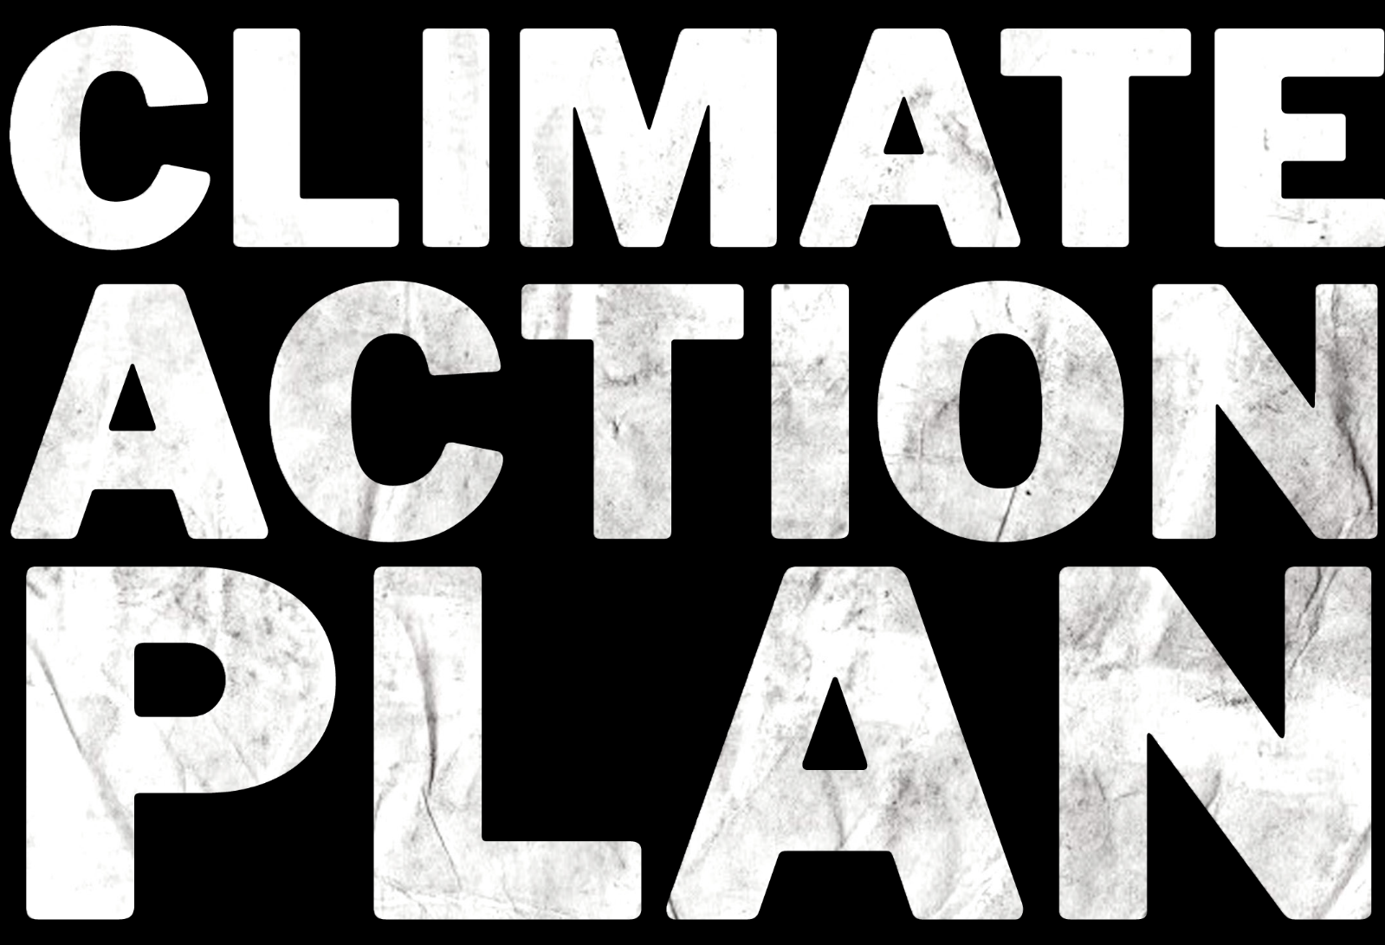

**FOR COUNCILS**

**A 50-point plan to tackle the climate and nature emergency.**

# What our council will do:

**Putting our climate at the heart of decision-making**

Our goal is to ensure that our climate and nature restoration goals are front and centre in all decision-making and investments, and inclusive engagement with citizens ensures that the changes made are sustainable.

## Tick

|  |  |  |
| --- | --- | --- |
| **1** | Require councillors to identify whether the recommendations put to them would help or hinder climate, air pollution and nature plans. |  |
| **2** | Identify both a councillor at cabinet level and a lead officer as Climate and Nature Champions who are required to publish a bi-annual independent and audited report to the public on progress in meeting climate change and nature targets. |  |
| **3** | Use additional decision-making approaches for complicated or contentious choices (such as representative Citizen Assemblies/Citizen’s Juries, participatory mapping and budgeting, etc). |  |
| **4** | Set interim and measurable targets for our council to achieve net zero greenhouse reductions and meet nature restoration goals. |  |
| **5** | Align all our council statutory and non-statutory plans, policies and guidance with respective carbon reduction pathways and nature restoration plans, including procurement. |  |
| **6** | Review and improve how we involve citizens in our existing decision-making processes. |  |

**Raising money**

Our goal is to have sufficient resource to invest in the changes needed to restore nature and meet climate goals, so that our council can reap the dividends and deliver our fair share of greenhouse gas reductions.

## Tick

|  |  |  |
| --- | --- | --- |
| **7** | Introduce a workplace car parking levy and/or similar initiative to fund sustainable transport. |  |
| **8** | Raise money from the UK Municipal Bonds Agency for low carbon infrastructure. |  |
| **9** | Use legal and planning mechanisms such as Section 106 agreements, Community Infrastructure Levy and other mechanisms to fund climate actions and nature restoration projects. |  |
| **10** | Implement licensing of the private rented sector to cover enforcement costs of minimum energy efficiency standards. (Applicable in England only) |  |

**Protect the most vulnerable**

Our goal is to ensure that those most vulnerable to the effects of climate change are properly supported and protected.

## Tick

|  |  |  |
| --- | --- | --- |
| **11** | Identify the most vulnerable people in the areas most at risk of flooding and high heat levels and target adaptation policies, actions and spending to these areas. |  |
| **12** | Ensure that voices of the most vulnerable communities are also represented in council decision-making and council-citizen deliberations. |  |

**Buildings**

Our goal is to ensure all homes are well insulated to minimum EPC C level and eradicate fuel poverty as fast as possible, and make a proportional contribution to the 1 million eco-heating heat pumps that need to be fitted in the UK each year.

## Tick

|  |  |  |
| --- | --- | --- |
| **13** | Retrofit council-owned properties with high levels of insulation. |  |
| **14** | Help owner-occupied homes be more energy efficient, for example by supporting energy companies to target fuel poor or vulnerable households with insulation. |  |
| **15** | Enforce minimum energy efficiency standards in the private rented sector. |  |
| **16** | Require higher standards than current national standards for privately built new homes. |  |
| **17** | Enforce building standards. |  |
| **18** | Require homes built on council land to be extremely energy efficient, using the Passivhaus standard or similar. |  |
| **19** | Develop a heating and energy efficiency strategy for the area. |  |

**Transport**

Our goal is to reduce air pollution to meet World Health Organisation levels, match European best practice in the use of buses, cycling and walking, and ensure all vehicles are zero emission.

## Tick

|  |  |  |
| --- | --- | --- |
| **20** | Enable the rapid shift to electric vehicles by installing Electric Vehicle (EV) charging points. |  |
| **21** | Prioritise transport investment into cycling, walking, trams and public transport, such as electric buses. |  |
| **22** | Put in place Clean Air Zones, with charging if needed. |  |
| **23** | Reduce car use through measures such as promoting car-sharing, re-regulating bus services and constraining road space. |  |
| **24** | Require all taxis and buses to be electric. |  |
| **25** | Deliver a rapid transition of the council’s own fleet to electric. |  |
| **26** | Require deliveries to the council to be by electric vehicles or bike (e.g. through setting-up a distribution centre for onward deliveries by clean vehicles). |  |
| **27** | Introduce differential charges for parking permits or other car related charges. |  |
| **28** | Reduce the need to own and use a car through managing developments in the local plan. |  |

**Power**

Our goal is to enable and support the growth and use of green energy, ensure energy is not wasted, and prevent the development of new fossil fuel extraction.

## Tick

|  |  |  |
| --- | --- | --- |
| **29** | Identify areas suitable for renewable energy in the local plan. |  |
| **30** | Switch street lighting to well-designed and well directed LED lights. |  |
| **31** | Reduce energy used by the council in its own estate. |  |
| **32** | Require the integration of renewable energy such as solar thermal, PV or heat pumps in council developments and, as much as possible, within private sector developments. |  |
| **33** | Support the development of renewable energy and energy storage. |  |
| **34** | Oppose fracking and other fossil fuel extraction, and where opposition on fracking has been overturned, support peaceful protest. (Applicable in England only). |  |
| **35** | Divest from fossil fuels and invest in renewable energy projects. |  |

**Waste**

Our goal is to be a zero waste area where all waste is minimised, recycled or reused as part of a circular economy approach.

## Tick

|  |  |  |
| --- | --- | --- |
| **36** | Send zero waste to landfill or incineration. |  |
| **37** | Use food waste according to the food waste hierarchy of prevent, reuse, recycle, and ensure remaining non-recyclable biodegradable waste to generate biogas. |  |
| **38** | Adopt circular economy waste policies in relevant plans and contracts. |  |
| **39** | Promote community sharing and reuse. |  |
| **40** | Ban the use of single-use plastic in council offices and premises. |  |

**Influencing others**

Our goal is to encourage and support other entities with their contribution to the fight against the climate emergency.

## Tick

|  |  |  |
| --- | --- | --- |
| **41** | Ensure the Sub-national Transport Body strategy is in-line with carbon budgets. (Applicable in England only) |  |
| **42** | Use council memberships of Local Enterprise Partnerships to ensure all their decisions are in-line with the climate reduction pathway and nature restoration plans. (Applicable in England only) |  |
| **43** | Provide particular support to SME businesses to access funds and expertise for reducing carbon pollution. |  |
| **44** | Use influence with schools and others to ensure that meals are delivered in accordance with the official Eatwell Guide on healthy eating and the majority of options on menus are healthy and plant-based, with less and better meat. |  |

**Land-use**

Our goal is to restore nature to help drawdown carbon pollution from the atmosphere and to ensure everyone has access to nature in nearby green spaces.

## Tick

|  |  |  |
| --- | --- | --- |
| **45** | Double tree cover on council-owned land, update local planning strategies to double tree cover across the Local Authority area, and ensure existing trees are properly protected in order to store carbon, support nature, improve soils and water quality, and aid flood protection and urban design. |  |
| **46** | Protect existing local green spaces, green belt and locally designated nature sites. |  |
| **47** | Manage council-owned land and road verges to increase biodiversity and drawdown carbon pollution, including through reduced pesticide use and increased planting of wildflowers. |  |
| **48** | Develop new quality green spaces in areas where they don’t exist, particularly in neighbourhoods where people are particularly vulnerable to heatwaves and/or are deprived of nature. |  |
| **49** | Produce a nature and ecosystem restoration plan to reverse and restore habitats and species and ecosystem quality and function. |  |

**Campaigning**

Our goal is to make our voice heard by the UK government and secure increased devolution to local level and increase democratic control.

## Tick

|  |  |  |
| --- | --- | --- |
| **50** | Work with other local authorities and allies to secure more regulatory powers, fundraising powers and finance to deliver on our aspirations (for example, as those identified by Friends of the Earth), and join forces with others to push for a climate action plan that is commensurate with the climate and nature emergency. |  |